**WEEK-5**

**Microservices with Spring Boot 3 and Spring Cloud**

**1. Creating Microservices for account and loan**

**AccountApplication.java**

package com.cognizant.account;  
  
import org.springframework.boot.SpringApplication;  
import org.springframework.boot.autoconfigure.SpringBootApplication;  
  
@SpringBootApplication  
public class AccountApplication {  
  
 public static void main(String[] args) {  
 SpringApplication.*run*(AccountApplication.class, args);  
 }  
  
}

**AccountController.java**

package com.cognizant.account.controller;  
  
import org.springframework.web.bind.annotation.*;  
  
import java.util.*;  
  
@RestController  
@RequestMapping("/accounts")  
public class AccountController {  
  
 @GetMapping("/{number}")  
 public Map<String, Object> getAccount(@PathVariable String number) {  
 Map<String, Object> response = new HashMap<>();  
 response.put("number", number);  
 response.put("type", "savings");  
 response.put("balance", 234343);  
 return response;  
 }  
}

**LoanApplication.java**

package com.cognizant.loan;  
  
import org.springframework.boot.SpringApplication;  
import org.springframework.boot.autoconfigure.SpringBootApplication;  
  
@SpringBootApplication  
public class LoanApplication {  
  
 public static void main(String[] args) {  
 SpringApplication.*run*(LoanApplication.class, args);  
 }  
  
}

**LoanController.java**

package com.cognizant.loan.controller;  
  
import org.springframework.web.bind.annotation.*;  
import java.util.*;  
  
@RestController  
@RequestMapping("/loans")  
public class LoanController {  
  
 @GetMapping("/{number}")  
 public Map<String, Object> getLoan(@PathVariable String number) {  
 Map<String, Object> response = new HashMap<>();  
 response.put("number", number);  
 response.put("type", "car");  
 response.put("loan", 400000);  
 response.put("emi", 3258);  
 response.put("tenure", 18);  
 return response;  
 }  
}

**Output:**

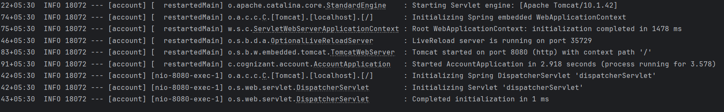

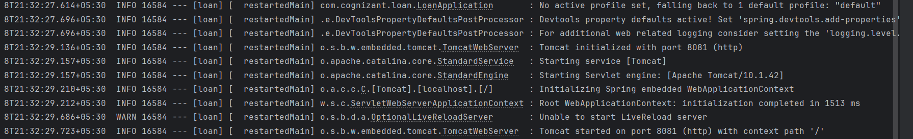

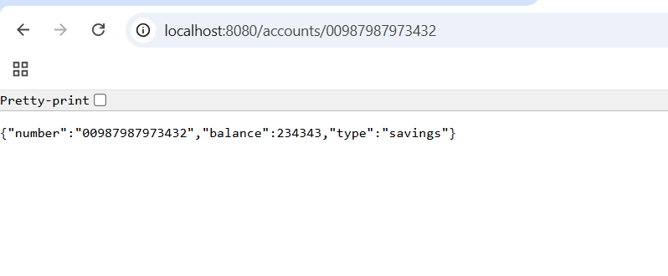

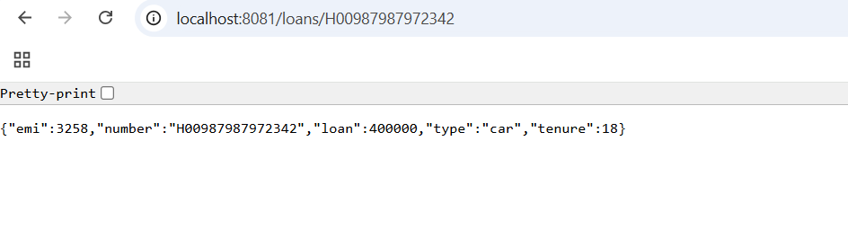

**2. Create Eureka Discovery Server and register microservices**

**EurekaDiscoveryServerApplication.java**

package com.cognizant.eureka_discovery_server;  
  
import org.springframework.boot.SpringApplication;  
import org.springframework.boot.autoconfigure.SpringBootApplication;  
import org.springframework.cloud.netflix.eureka.server.EnableEurekaServer;  
  
@SpringBootApplication  
@EnableEurekaServer  
public class EurekaDiscoveryServerApplication {  
 public static void main(String[] args) {  
 SpringApplication.*run*(EurekaDiscoveryServerApplication.class, args);  
 }  
}

**application.properties**

spring.application.name=eureka-discovery-server  
server.port=8761  
  
eureka.client.register-with-eureka=false  
eureka.client.fetch-registry=false  
  
logging.level.com.netflix.eureka=OFF  
logging.level.com.netflix.discovery=OFF

**pom.xml**

<?xml version="1.0" encoding="UTF-8"?>  
<project xmlns="http://maven.apache.org/POM/4.0.0" xmlns:xsi="http://www.w3.org/2001/XMLSchema-instance"  
 xsi:schemaLocation="http://maven.apache.org/POM/4.0.0 https://maven.apache.org/xsd/maven-4.0.0.xsd">  
 <modelVersion>4.0.0</modelVersion>  
 <parent>  
 <groupId>org.springframework.boot</groupId>  
 <artifactId>spring-boot-starter-parent</artifactId>  
 <version>3.5.3</version>  
 <relativePath/>   
 </parent>  
 <groupId>com.cognizant</groupId>  
 <artifactId>eureka-discovery-server</artifactId>  
 <version>0.0.1-SNAPSHOT</version>  
 <name>eureka-discovery-server</name>  
 <description>Demo project for Spring Boot</description>  
 <url/>  
 <licenses>  
 <license/>  
 </licenses>  
 <developers>  
 <developer/>  
 </developers>  
 <scm>  
 <connection/>  
 <developerConnection/>  
 <tag/>  
 <url/>  
 </scm>  
 <properties>  
 <java.version>17</java.version>  
 <spring-cloud.version>2025.0.0</spring-cloud.version>  
 </properties>  
 <dependencies>  
 <dependency>  
 <groupId>org.springframework.cloud</groupId>  
 <artifactId>spring-cloud-starter-netflix-eureka-client</artifactId>  
 </dependency>  
 <dependency>  
 <groupId>org.springframework.cloud</groupId>  
 <artifactId>spring-cloud-starter-netflix-eureka-server</artifactId>  
 </dependency>  
  
 <dependency>  
 <groupId>org.springframework.boot</groupId>  
 <artifactId>spring-boot-starter-test</artifactId>  
 <scope>test</scope>  
 </dependency>  
 </dependencies>  
 <dependencyManagement>  
 <dependencies>  
 <dependency>  
 <groupId>org.springframework.cloud</groupId>  
 <artifactId>spring-cloud-dependencies</artifactId>  
 <version>${spring-cloud.version}</version>  
 <type>pom</type>  
 <scope>import</scope>  
 </dependency>  
 </dependencies>  
 </dependencyManagement>  
  
 <build>  
 <plugins>  
 <plugin>  
 <groupId>org.springframework.boot</groupId>  
 <artifactId>spring-boot-maven-plugin</artifactId>  
 </plugin>  
 </plugins>  
 </build>  
  
</project>

**AccountApplication.java**

package com.cognizant.account;  
  
import org.springframework.boot.SpringApplication;  
import org.springframework.boot.autoconfigure.SpringBootApplication;  
import org.springframework.cloud.client.discovery.EnableDiscoveryClient;  
  
@SpringBootApplication  
@EnableDiscoveryClient  
public class AccountApplication {  
 public static void main(String[] args) {  
 SpringApplication.*run*(AccountApplication.class, args);  
 }  
}

**AccountController.java**

package com.cognizant.account;  
  
import org.springframework.web.bind.annotation.*;  
import java.util.Map;  
  
@RestController  
@RequestMapping("/accounts")  
public class AccountController {  
  
 @GetMapping("/{number}")  
 public Map<String, Object> getAccount(@PathVariable String number) {  
 return Map.*of*(  
 "number", number,  
 "type", "savings",  
 "balance", 234343  
 );  
 }  
}

**application.properties**

server.port=8080  
spring.application.name=account-service  
eureka.client.service-url.defaultZone=http://localhost:8761/eureka  
spring.cloud.compatibility-verifier.enabled=false

**pom.xml**

<?xml version="1.0" encoding="UTF-8"?>  
<project xmlns="http://maven.apache.org/POM/4.0.0"  
 xmlns:xsi="http://www.w3.org/2001/XMLSchema-instance"  
 xsi:schemaLocation="http://maven.apache.org/POM/4.0.0 https://maven.apache.org/xsd/maven-4.0.0.xsd">  
  
 <modelVersion>4.0.0</modelVersion>  
  
 <parent>  
 <groupId>org.springframework.boot</groupId>  
 <artifactId>spring-boot-starter-parent</artifactId>  
 <version>3.1.6</version>  
 <relativePath/>  
 </parent>  
  
 <groupId>com.cognizant</groupId>  
 <artifactId>account</artifactId>  
 <version>0.0.1-SNAPSHOT</version>  
 <name>account</name>  
 <description>Account Microservice for Eureka</description>  
  
 <properties>  
 <java.version>17</java.version>  
 <spring-cloud.version>2022.0.4</spring-cloud.version>  
 </properties>  
  
 <dependencies>  
 <!-- Spring Web -->  
 <dependency>  
 <groupId>org.springframework.boot</groupId>  
 <artifactId>spring-boot-starter-web</artifactId>  
 </dependency>  
  
 <!-- Eureka Client -->  
 <dependency>  
 <groupId>org.springframework.cloud</groupId>  
 <artifactId>spring-cloud-starter-netflix-eureka-client</artifactId>  
 </dependency>  
  
 <!-- DevTools -->  
 <dependency>  
 <groupId>org.springframework.boot</groupId>  
 <artifactId>spring-boot-devtools</artifactId>  
 <scope>runtime</scope>  
 <optional>true</optional>  
 </dependency>  
  
 <!-- Test -->  
 <dependency>  
 <groupId>org.springframework.boot</groupId>  
 <artifactId>spring-boot-starter-test</artifactId>  
 <scope>test</scope>  
 </dependency>  
 </dependencies>  
  
 <dependencyManagement>  
 <dependencies>  
 <dependency>  
 <groupId>org.springframework.cloud</groupId>  
 <artifactId>spring-cloud-dependencies</artifactId>  
 <version>${spring-cloud.version}</version>  
 <type>pom</type>  
 <scope>import</scope>  
 </dependency>  
 </dependencies>  
 </dependencyManagement>  
  
 <build>  
 <plugins>  
 <plugin>  
 <groupId>org.springframework.boot</groupId>  
 <artifactId>spring-boot-maven-plugin</artifactId>  
 </plugin>  
 </plugins>  
 </build>  
  
</project>

**LoanApplication.java**

package com.cognizant.loan;  
  
import org.springframework.boot.SpringApplication;  
import org.springframework.boot.autoconfigure.SpringBootApplication;  
import org.springframework.cloud.client.discovery.EnableDiscoveryClient;  
  
@SpringBootApplication  
@EnableDiscoveryClient  
public class LoanApplication {  
 public static void main(String[] args) {  
 SpringApplication.*run*(LoanApplication.class, args);  
 }  
}

**LoanController.java**

package com.cognizant.loan.controller;  
  
import org.springframework.web.bind.annotation.*;  
import java.util.*;  
  
@RestController  
@RequestMapping("/loans")  
public class LoanController {  
  
 @GetMapping("/{number}")  
 public Map<String, Object> getLoan(@PathVariable String number) {  
 Map<String, Object> response = new HashMap<>();  
 response.put("number", number);  
 response.put("type", "car");  
 response.put("loan", 400000);  
 response.put("emi", 3258);  
 response.put("tenure", 18);  
 return response;  
 }  
}

**application.properties**

server.port=8081  
spring.application.name=loan-service  
  
eureka.client.service-url.defaultZone=http://localhost:8761/eureka  
eureka.client.register-with-eureka=true  
eureka.client.fetch-registry=true

**pom.xml**

<project xmlns="http://maven.apache.org/POM/4.0.0"  
 xmlns:xsi="http://www.w3.org/2001/XMLSchema-instance"  
 xsi:schemaLocation="http://maven.apache.org/POM/4.0.0 https://maven.apache.org/xsd/maven-4.0.0.xsd">  
  
 <modelVersion>4.0.0</modelVersion>  
  
 <parent>  
 <groupId>org.springframework.boot</groupId>  
 <artifactId>spring-boot-starter-parent</artifactId>  
 <version>3.1.8</version>  
 <relativePath />  
 </parent>  
  
 <groupId>com.cognizant</groupId>  
 <artifactId>loan</artifactId>  
 <version>0.0.1-SNAPSHOT</version>  
 <name>loan</name>  
  
 <properties>  
 <java.version>17</java.version>  
 <spring-cloud.version>2022.0.4</spring-cloud.version>  
 </properties>  
  
 <dependencies>  
 <!-- Spring Web -->  
 <dependency>  
 <groupId>org.springframework.boot</groupId>  
 <artifactId>spring-boot-starter-web</artifactId>  
 </dependency>  
  
 <!-- Eureka Client -->  
 <dependency>  
 <groupId>org.springframework.cloud</groupId>  
 <artifactId>spring-cloud-starter-netflix-eureka-client</artifactId>  
 </dependency>  
  
 <!-- Devtools (Optional) -->  
 <dependency>  
 <groupId>org.springframework.boot</groupId>  
 <artifactId>spring-boot-devtools</artifactId>  
 <scope>runtime</scope>  
 <optional>true</optional>  
 </dependency>  
  
 <!-- Testing -->  
 <dependency>  
 <groupId>org.springframework.boot</groupId>  
 <artifactId>spring-boot-starter-test</artifactId>  
 <scope>test</scope>  
 </dependency>  
 </dependencies>  
  
 <dependencyManagement>  
 <dependencies>  
 <dependency>  
 <groupId>org.springframework.cloud</groupId>  
 <artifactId>spring-cloud-dependencies</artifactId>  
 <version>${spring-cloud.version}</version>  
 <type>pom</type>  
 <scope>import</scope>  
 </dependency>  
 </dependencies>  
 </dependencyManagement>  
  
 <build>  
 <plugins>  
 <plugin>  
 <groupId>org.springframework.boot</groupId>  
 <artifactId>spring-boot-maven-plugin</artifactId>  
 </plugin>  
 </plugins>  
 </build>  
</project>

**LoggingFilter.java**

package com.cognizant.apigateway.filters;  
  
import org.springframework.cloud.gateway.filter.GlobalFilter;  
import org.springframework.core.Ordered;  
import org.springframework.stereotype.Component;  
import org.springframework.web.server.ServerWebExchange;  
import reactor.core.publisher.Mono;  
  
@Component  
public class LoggingFilter implements GlobalFilter, Ordered {  
 @Override  
 public Mono<Void> filter(ServerWebExchange exchange, org.springframework.cloud.gateway.filter.GatewayFilterChain chain) {  
 System.out.println("Incoming request: " + exchange.getRequest().getPath());  
 return chain.filter(exchange);  
 }  
  
 @Override  
 public int getOrder() {  
 return -1;  
 }  
}

**ApiGatewayApplication.java**

package com.cognizant.api_gateway;  
  
import org.springframework.boot.SpringApplication;  
import org.springframework.boot.autoconfigure.SpringBootApplication;  
@EnableDiscoveryClient  
@SpringBootApplication  
public class ApiGatewayApplication {  
 public static void main(String[] args) {  
 SpringApplication.run(ApiGatewayApplication.class, args);  
 }  
}

**application.properties**

server.port=9090  
spring.application.name=api-gateway  
eureka.client.service-url.defaultZone=http://localhost:8761/eureka  
  
spring.cloud.gateway.routes[0].id=account-service  
spring.cloud.gateway.routes[0].uri=lb://account-service  
spring.cloud.gateway.routes[0].predicates[0]=Path=/accounts/**  
  
spring.cloud.gateway.routes[1].id=loan-service  
spring.cloud.gateway.routes[1].uri=lb://loan-service  
spring.cloud.gateway.routes[1].predicates[0]=Path=/loans/**

**pom.xml**

<?xml version="1.0" encoding="UTF-8"?>  
<project xmlns="http://maven.apache.org/POM/4.0.0" xmlns:xsi="http://www.w3.org/2001/XMLSchema-instance"  
 xsi:schemaLocation="http://maven.apache.org/POM/4.0.0 https://maven.apache.org/xsd/maven-4.0.0.xsd">  
 <modelVersion>4.0.0</modelVersion>  
 <parent>  
 <groupId>org.springframework.boot</groupId>  
 <artifactId>spring-boot-starter-parent</artifactId>  
 <version>3.5.3</version>  
 <relativePath/>  
 </parent>  
 <groupId>com.cognizant</groupId>  
 <artifactId>api-gateway</artifactId>  
 <version>0.0.1-SNAPSHOT</version>  
 <name>api-gateway</name>  
 <description>Demo project for Spring Boot</description>  
 <url/>  
 <licenses>  
 <license/>  
 </licenses>  
 <developers>  
 <developer/>  
 </developers>  
 <scm>  
 <connection/>  
 <developerConnection/>  
 <tag/>  
 <url/>  
 </scm>  
 <properties>  
 <java.version>17</java.version>  
 <spring-cloud.version>2025.0.0</spring-cloud.version>  
 </properties>  
 <dependencies>  
 <dependency>  
 <groupId>org.springframework.cloud</groupId>  
 <artifactId>spring-cloud-starter-gateway-server-webmvc</artifactId>  
 </dependency>  
 <dependency>  
 <groupId>org.springframework.cloud</groupId>  
 <artifactId>spring-cloud-starter-netflix-eureka-client</artifactId>  
 </dependency>  
  
 <dependency>  
 <groupId>org.springframework.boot</groupId>  
 <artifactId>spring-boot-starter-test</artifactId>  
 <scope>test</scope>  
 </dependency>  
 </dependencies>  
 <dependencyManagement>  
 <dependencies>  
 <dependency>  
 <groupId>org.springframework.cloud</groupId>  
 <artifactId>spring-cloud-dependencies</artifactId>  
 <version>${spring-cloud.version}</version>  
 <type>pom</type>  
 <scope>import</scope>  
 </dependency>  
 </dependencies>  
 </dependencyManagement>  
  
 <build>  
 <plugins>  
 <plugin>  
 <groupId>org.springframework.boot</groupId>  
 <artifactId>spring-boot-maven-plugin</artifactId>  
 </plugin>  
 </plugins>  
 </build>  
  
</project>

**Output**

